

**Gigabit Resources**

**Our National Partners**

National Science Foundation CISE - <https://www.nsf.gov/dir/index.jsp?org=CISE>

Mozilla - [https://learning.mozilla.org/gigabit](https://learning.mozilla.org/en-US/gigabit)

US Ignite - [www.us-ignite.org/](https://www.us-ignite.org/)

Next Century Cities - <http://nextcenturycities.org/>

**Helpful Resources**

Mozilla Web Literacy Map + Curriculum - [mzl.la/webliteracymap](https://learning.mozilla.org/en-US/web-literacy)

Mozilla Learning Network - [learning.mozilla.org](https://learning.mozilla.org/en-US/)

Mozilla Gigabit Video - [mzl.la/MozGigVid](https://mzl.la/MozGigVid)

National Resource Network: ‘*Access and Inclusion in the Digital Age*’ - [goo.gl/EJnZYK](http://www.nationalresourcenetwork.org/en/Document/306284/Access_and_Inclusion_in_the_Digital_Age_A_Resource_Guide_for_Local_Governments)

**Funding Databases**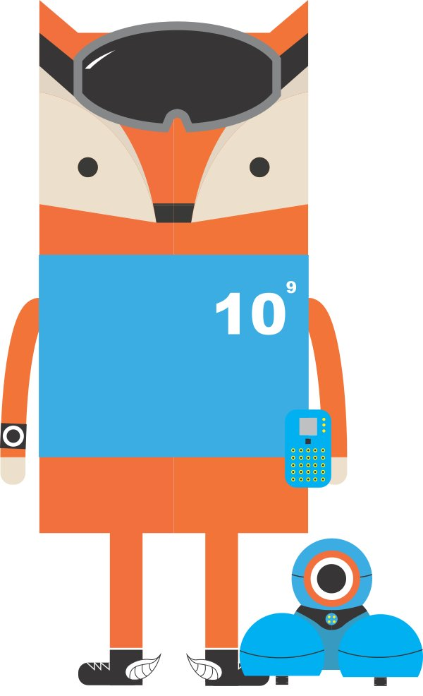

Grantmakers for Education - [www.edfunders.org/](http://www.edfunders.org/)

Federal Grant Database - [www.grants.gov/](http://www.grants.gov/)

Grant Watch - [www.grantwatch.com/](https://www.grantwatch.com/)

Inside Philanthropy - [www.insidephilanthropy.com/](http://www.insidephilanthropy.com/)

Foundation Center Directory - <https://fconline.foundationcenter.org/>

Arizona Community Foundation - https://www.azfoundation.org/

**Mozilla Gigabit Community Fund:**

Program Details - <https://learning.mozilla.org/gigabit>

Project Portfolio - <https://learning.mozilla.org/gigabit/portfolio>

|  |  |
| --- | --- |
| **VIATOR**  Using virtual reality to submerge users in an  immersive environment for an interactive,  engaging language learning experience. | **GIGABOTS**  Building connected robotics that allow students to program and interact with robots across any distance in real time. |
| **4K MICROSCOPY**  Harnessing the gig and 4K video microscopy to create connections + collaborations for powerful STEM learning opportunities in Chattanooga and beyond. | **READ2THINK**  Measuring a child’s reading fluency using  artificial intelligence to assess speed,vocabulary, understanding, sight word, pronunciation, and phonics recognition. |

CC-BY [Mozilla](https://learning.mozilla.org)

Help us improve this activity! Contact [the Gigabit Team](mailto:gigabit@mozilla.com) at Mozilla.